Girlguiding Scotland
Trustee (member and external)
Role description and information


girlguidingscotland.org.uk

Welcome

Thank you for your interest in applying for this volunteer role.

Volunteers are at the heart of Girlguiding – all our units are powered by them! Our volunteers help us in all sorts of ways, from running and supporting units, through to county roles, to being trustees. Our mission at Girlguiding Scotland is to inspire and empower girls all across Scotland and our volunteers are key to achieving this.

We’re looking for new trustees to join our board. A board of trustees is the group of individuals responsible for a charity's governance and setting and overseeing the strategy. They ensure the organisation is administered effectively, and accounts for its activities and outcomes. We’re looking to recruit a trustee who is currently an active member of Girlguiding and a trustee who is not.

As the leading charity for girls and young women in Scotland, it is important to us that our volunteer team includes people with different skills, knowledge and lived experiences. This time we are looking for people with experience in one or more of the following areas - commercial acumen and funding; communications, marketing & branding; stakeholder engagement; IT & digital skills.

We’d really encourage you to think about putting yourself forward for this exciting role. By volunteering at a national level, you’ll ensure that Girlguiding Scotland’s strategy is fit for purpose and will impact the lives of thousands of girls across Scotland.

We strive to be welcoming and inclusive, and we encourage applications from people of all backgrounds and all extents of guiding experience. In particular, we would welcome applications from people with a disability and people from ethnic minority groups.

If you need support to help you apply, or need this information in a printed or other format, please let us know in advance so that we can ensure appropriate arrangements are made. Contact details can be found at the end of this pack.

Please take some time to read through the pack to learn more about becoming a Girlguiding Scotland trustee and all the benefits it might bring you personally and professionally, as well as the impact your input could have on the organisation.
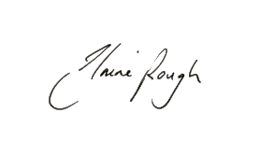
Best wishes,

Elaine Rough
Scottish Chief Commissioner

About Girlguiding Scotland
With nearly 40,000 young members and powered by 9,000 volunteers, Girlguiding Scotland is the largest charity for girls and young women in Scotland. Thanks to the dedication and support of our amazing volunteers, we are active in every part of Scotland.

Our approach at Girlguiding Scotland is two-fold. We support and develop volunteer teams to deliver guiding in local areas, and we provide high quality events and experiences at a national level that encourage volunteers to make a difference to the lives of girls across Scotland. You can find out more about our organisation on our website.

Our structure
Girlguiding Scotland is part of Girlguiding but operates with its own governance structure, volunteer leadership and staff team. We support local guiding through 27 counties across Scotland.

Our current governance structure is made up of the following groups:
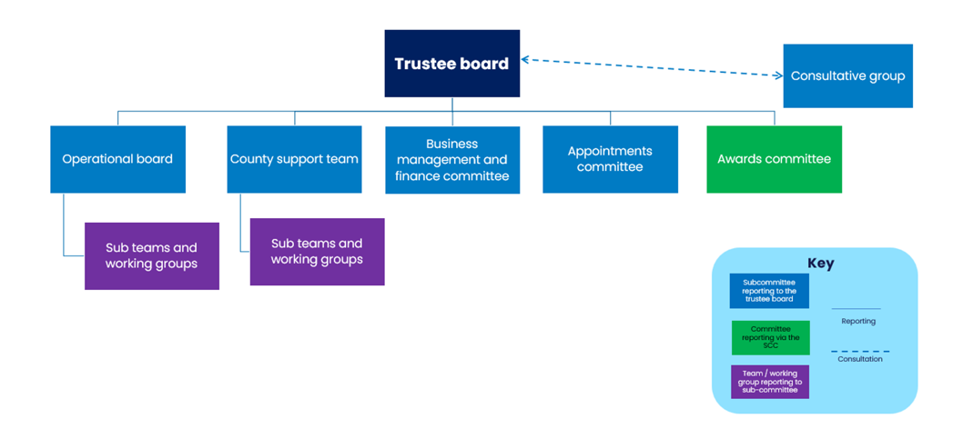

Both trustee roles are part of the trustee board.

This role involves working collaboratively with other trustees, the Scottish chief commissioner team, other Scottish lead volunteers, the chief executive and other members of the staff team.

Our priorities
We share Girlguiding’s vision, mission and values for the organisation, and the goals set out in Girlguiding’s strategy to:
- create unrivalled experiences for girls, led by girls,
- develop a rewarding and flexible volunteer experience,
- be more inclusive, impactful and visible, so we’re accessible to more girls, and
- create a sustainable, efficient organisation.

In 2023, after reviewing our strategic priorities alongside emerging external threats and opportunities, our trustees and members of the operational board clearly identified that an increased focus on volunteer recruitment and retention is essential to achieving our mission. Until 2028, we are focusing on four dedicated programmes of work to make volunteering with Girlguiding Scotland more desirable, more welcoming and even more rewarding. More information about our plans can be found on our website.

Principles of working together
We follow the principle that all people and groups in Girlguiding are part of one team. This means that:

- We are inclusive – we work together to create an environment where everyone feels an equal sense of belonging and is free to be themselves – whoever they are and wherever they’re from. We value and celebrate difference and represent the diversity of the communities we seek to serve.

- We’re open and collaborative – we uphold the principle of co-production so that everything we do is designed and delivered with users – whether volunteers, girls or wider society. All key stakeholders are identified and informed or involved from the start of any piece of work so together we achieve the best possible outcomes in the most efficient way.

- We put girls at the centre – we are ambitious on behalf of our girls, young women and volunteers and challenge every activity that doesn’t support the Girlguiding mission. Regardless of role, function or level, all members of our team focus on the common good, and how we can best use our collective resources to deliver what girls tell us they want and need.

The role
As a trustee, you will be an active member of the Girlguiding Scotland trustee board, which is chaired by the chief commissioner. The board is collectively responsible for the governance and overall effective management of Girlguiding Scotland. The trustee board ensures that Girlguiding Scotland works within the legal, charitable, and financial requirements of a charity, meets regulatory requirements and promotes good practice.
The board focuses on the strategy and performance of Girlguiding Scotland ensuring we continue to develop in response to member needs. Currently the main focus for our work is on providing a motivating and rewarding volunteer experience so that we can build capacity to enable more girls to join Girlguiding in Scotland, thereby ensuring we can sustain the organisation for the future.
You must be eligible to serve as a trustee of a charity, including being aged 18 or over at the time of appointment. Find out more here about who can be a trustee.
Responsibilities & tasks
- Contribute to shaping the future direction for Girlguiding Scotland and be responsible for ensuring the charity meets all legal obligations.
- Actively contribute to the work of the trustee board by preparing for meetings and engaging in discussions; bringing your judgement to collective decision making.
The practicalities
- We are looking for one trustee who is an active adult member of Girlguiding and one trustee who is not.
- You must be eligible to serve as a trustee of a charity in Scotland, including being aged 18 or over at the time of appointment. Find out more here about who can be a trustee. We encourage applications from young adult members.
- This role involves working collaboratively with other trustees, the Scottish chief commissioner team, other Scottish lead volunteers, the chief executive and other members of the staff team, during and outwith board meetings.
- There are usually four trustee board meetings a year plus a residential weekend. Meetings of the trustee board are generally held as hybrid meetings, mostly taking place in Edinburgh and online, usually on Saturdays.
- There may be instances when additional meetings are required to discuss specific topics. These will often by held via online meeting.
- Trustees are also encouraged to attend one or two meetings of the Girlguiding Scotland consultative group each year – there are usually three meetings of the group each year, one in-person meeting on a Saturday and two online evening meetings.
- In addition to attending the meetings, preparation time will be required. This may involve preparing a report or paper and will always involve reading papers circulated in advance. Meeting papers are usually circulated around 2 weeks before the meeting.
- Expenses for travel & subsistence may be claimed. We can provide the resources that you need to undertake this role.
- This role is for 3 years and can be extended by mutual agreement for up to a further 2 years.
Induction, training and support
- All volunteers are given an in-depth induction into their role. Participation in the induction programme is a necessary part of taking on this role.
- Training will be provided to ensure that all volunteers are able to fulfil their roles and responsibilities. We will continue to provide support and development opportunities throughout your time as a trustee. We have a trustee review and development framework in place, offering opportunities to develop your knowledge and skills. Trustees are asked to take part in regular review meetings with the chair of the board.
What you’ll gain from this role
As a Girlguiding Scotland trustee, you’ll have the opportunity to use your skills, knowledge and experience to support our work. You’ll make a difference to the lives of thousands of girls. If you’re passionate about supporting an organisation to run and making a difference, then this could be the role for you!
This role brings lots of opportunities to learn and develop your own skills, both personally and professionally, we’ve listed some of them below.
- Leadership - You’ll experience different leadership and chairing styles, and hone your own leadership skills further.
- Strategy - You’ll explore data, evidence, and forecasting to help to develop and oversee the delivery of ambitious strategies for Girlguiding Scotland.
- Governance - You’ll be part of a board demonstrating what good governance looks like, being proactive in monitoring compliance, dealing with legislation and regulation, and safeguarding our reputation.
- Network - This role gives you an opportunity to work with a wide range of other people, volunteers, staff and external advisors.
- You - You’ll lead and participate in respectful debate, critical thinking, and values-led decision-making, and dedicate your knowledge and skills to an important cause.
Your profile
At Girlguiding Scotland, striving to be an inclusive and impactful organisation is at the heart of what we do. We recognise that being a great volunteer isn’t just about the skills that you can bring to the table, but also the unique perspectives that come from your background and life experiences.
Prior experience of volunteering at Girlguiding Scotland level is not required for this role.

The key skills, experience and attributes that we’re looking for are:

- Eligible to serve as a trustee of a charity, including being aged 18 or over at the time of appointment. | Essential
- Committed to our values. | Essential
- Experience in one or more of the following areas either from a professional or voluntary role - commercial acumen and funding; communications, marketing & branding; stakeholder engagement; IT & digital skills | Essential
- A relevant qualification or formal training in one of the above listed areas. | Desirable
- Some experience of being a member of a committee or board | Desirable
- Confident to speak up and ensure your views are heard | Essential
- Capacity to be proactive and involved in building relationships with key volunteers and staff to facilitate the work between meetings | Essential
- Proactive in reviewing papers and considering views before meetings | Essential
- Excited to be part of shaping the future and responding to challenges | Essential
- Approachable and open minded, and able to work with others | Essential
- Ability to think of the bigger picture for the benefit of members and potential members across Scotland | Essential

We recognise that volunteers interested in this role may not meet all of these requirements. We strive to be welcoming and inclusive, and we encourage applications from people of all backgrounds and extents of guiding experience. In particular, we would welcome applications from people with a disability and people from ethnic minority groups.

How to apply
If you would like to have an informal chat, please get in touch with Cat Campbell, governance and compliance manager on cat.campbell@girlguiding-scot.org.uk.

Girlguiding Scotland values inclusivity, and so we welcome requests for support or reasonable adjustments during the recruitment process. If you need any support to complete your application or need this information in a printed or other format, please let us know in advance so that we can ensure appropriate arrangements are made - please get in touch with Cat on 0131 226 4511.

To apply, please email governance@girlguiding-scot.org.uk with your full name, membership number (if you are a member) and contact details. Please include the names and contact details of two referees you feel could comment on your suitability for this role. Your referees should be current members of Girlguiding; one of whom should be from a level above you, for example, your local or county commissioner.

In addition to providing your personal details, please also answer the two questions below.

Q1. Why are you interested in this role? (500 words max)

Q2. What skills and experiences can you bring to this role? (500 words max)

Please include the role title (trustee) in the subject line of the email.
The deadline for applications is Sunday 11 October at 11.59pm.

Please note that, if you are a current member, we will look at your GO record to check role history, training, qualifications, and awards as part of the recruitment process.

